Assignment -1

|  |  |
| --- | --- |
| Student Name | DIVYAJOTHY |
| Student Roll Number | 7376191CS162 |

**Question-1:**

Create registration page in html with username, email and phone number and by using POST method display it in next html page.

**CODE:**

HTML

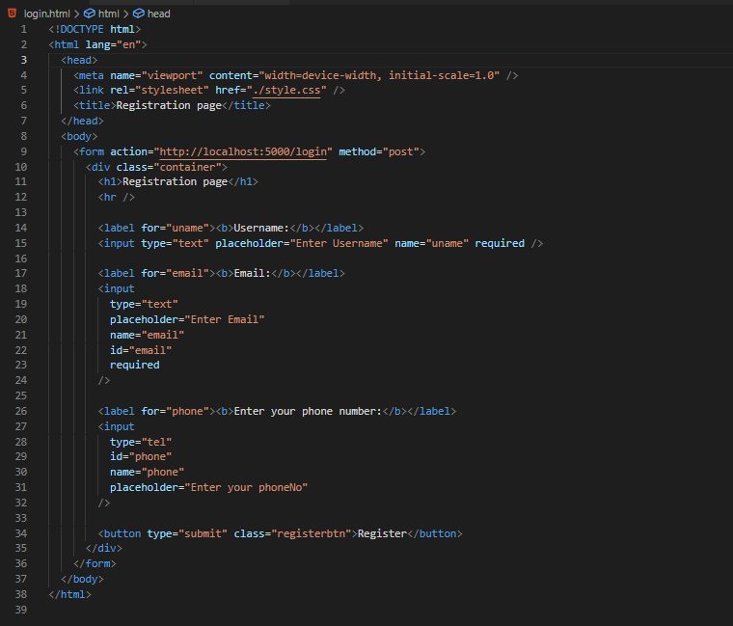

**display.html**

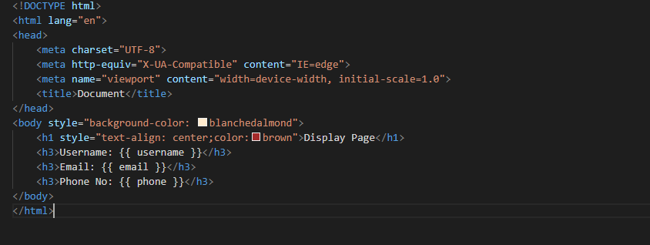

**FLASK PYTHON**

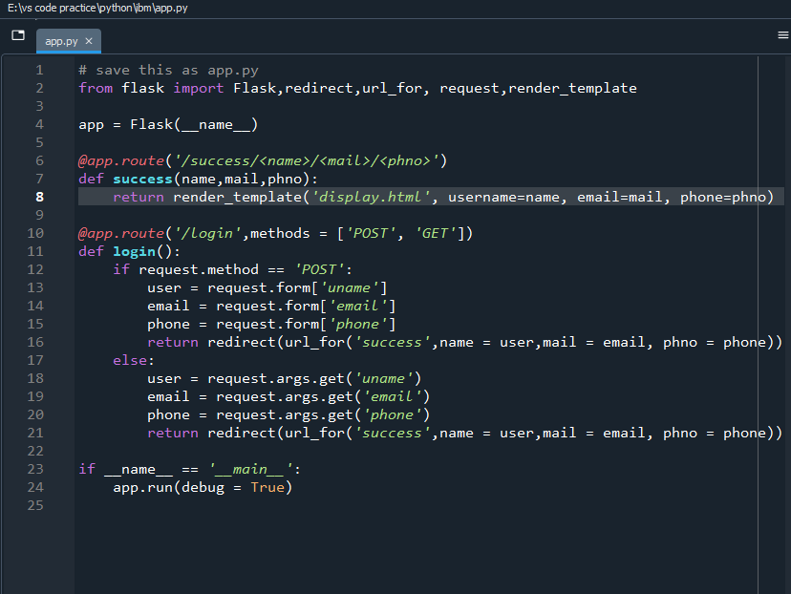

**OUTPUT**

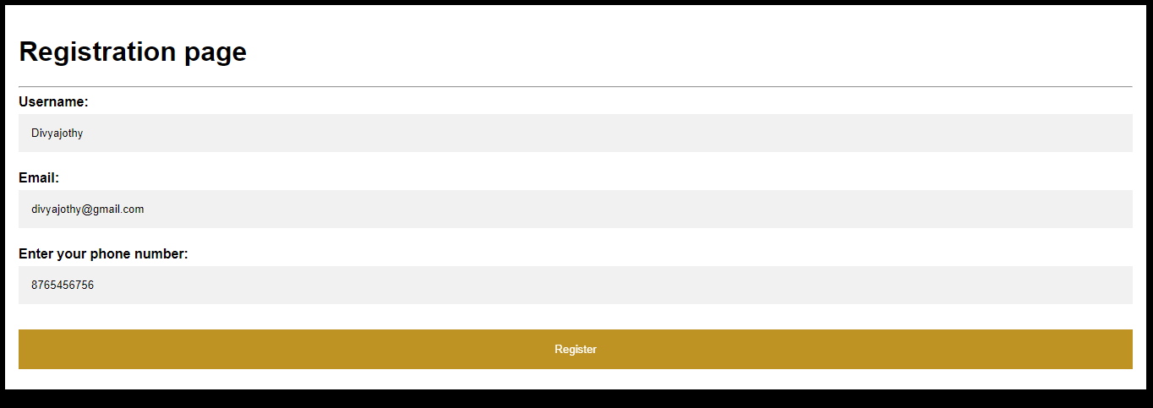



**Question-2:**

Develop a flask program which should contain atleast 5 packages used from pypi.org.

**Packages used :**

1. from __future__ import print_function

2. import sys

3. from datetime import datetime

4. from flask import Flask,redirect

5. import emoji

6. from urllib.request import urlope

**Code:**

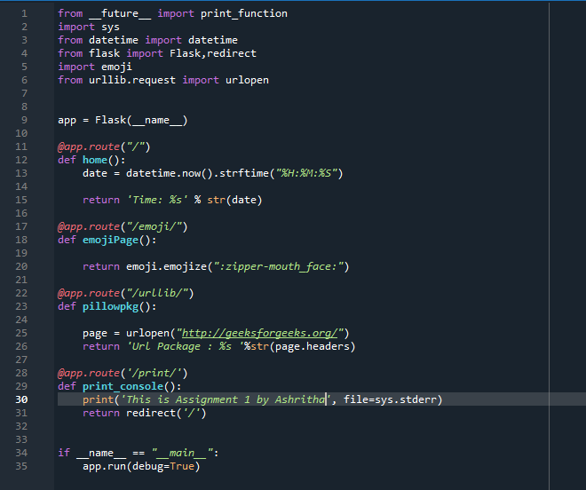

**Output:**

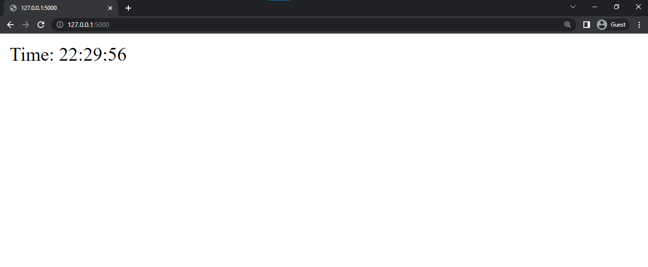

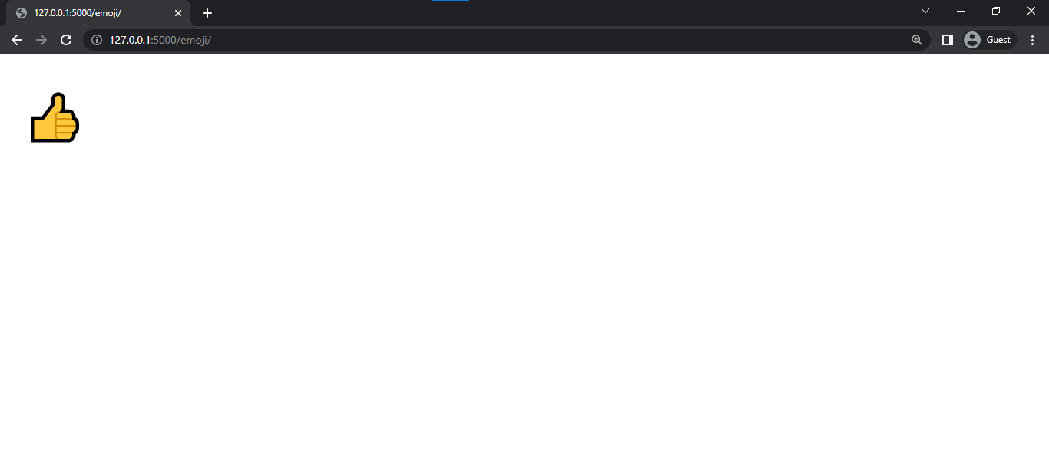

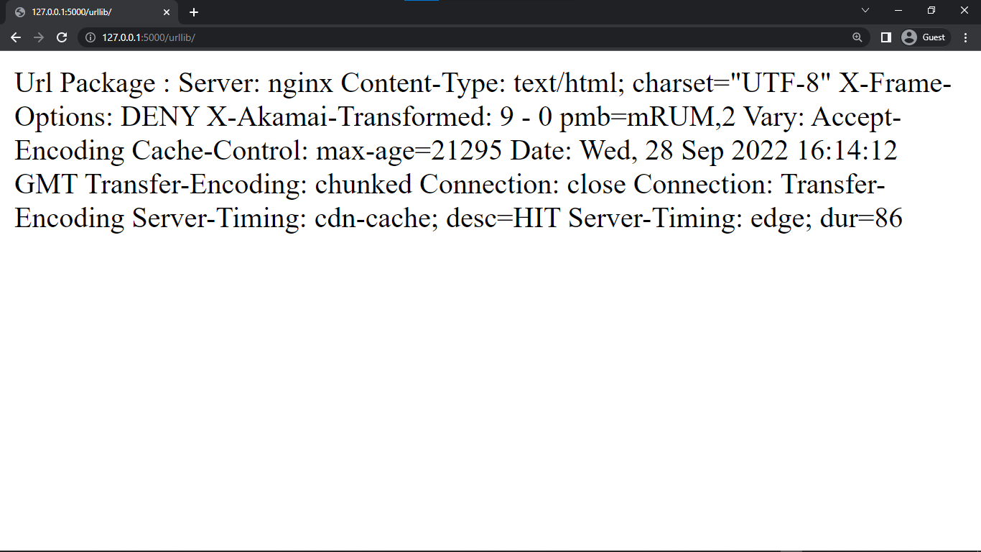

**Print in console**

